Reverse Parking Radar Project User Manual

V1.0

- Introduction
Proper use and maintenance of the product are the guarantees for its normal operation and full performance. This manual introduces the use and maintenance of the 60GHz millimeter-wave radar F302 from aspects such as its composition, installation method, usage procedure, and common problem troubleshooting. To better use and maintain this product, please read it carefully.
- Equipment List
  - Hardware Equipment
In this set of Demo demonstration tools, the hardware equipment uses the AT60L2AA12-1211 module (1T2R AIP). The physical diagram is shown in Figure 1.
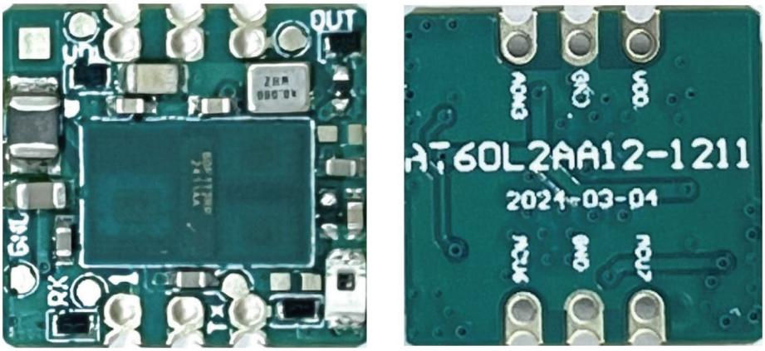

Figure 1 Hardware Physical Diagram

  - Software Composition
The software materials mainly include the upper computer display software, as shown in Table 1.
Table 1 Software List
Serial Number | Name | Number | Document name
1 | Upper computer display software | 1 份 | Rearview Radar Host Computer Software V2.0.rar
- Preparations Before Testing
  - Viewing of Port Numbers of USB to Serial Port Conversion Module
    - Communication Interface
The radar module communicates with the upper computer software via the serial port (UART) with a baud rate of 115200. The communication protocol can be found in "60GHz Millimeter Wave Radar F302 Serial Port Communication Protocol Specification V1.1".
On each side of the radar module, there is a row of half-hole interfaces with a spacing of 2mm. There are a total of five effective signal interfaces: +3.3V, GNG, I/O, RX, and TX, as shown in Figure 2 and Table 2 which provides the definitions and descriptions of each pin.
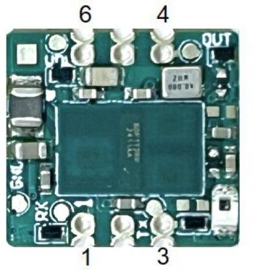
Figure 2 Definition of Pins for Radar Module
Table 2 Definition and Description of Module Pins

Pin number | Stencil printing | Attribute | Pin Definition | Description
1 | M7 | I/O | Radar_Rx | UART_Rx pin (download, communication port)
2 | GND | P | Grounding | Workplace
3 | M6 | I/O | Radar_Tx | UART_Tx pin (download, communication port)
4 | A3 | I/O | GPIO output pin | Radar sensing output pin: High level when an alarm occurs, low level when no alarm is triggered.
5 | GND | P | Grounding | Workplace
6 | VDD | P | Power supply pin | DC 3.3V OR 5.0V

Note: The maximum voltage for power supply is +5.5V. Operating beyond or equal to this limit voltage will damage the chip, and in severe cases, it may even destroy the chip.
When demonstrating this set of Demo, only the +3.3V, GNG, RX, and TX interfaces need to be used.

    - Port Number Check
Connect the USB to Serial Port module to the computer and install the driver. Then, open the Device Manager in the computer (on the desktop, in "This PC" or "Computer", right-click and select "Manage", and then select "Device Manager" from the left window). You can check the driver status as shown in Figure 3. The serial port port number is COM46 (note: you need to connect the USB to Serial Port module to the computer and install the driver correctly before the "USB Serial Port..." can be displayed).

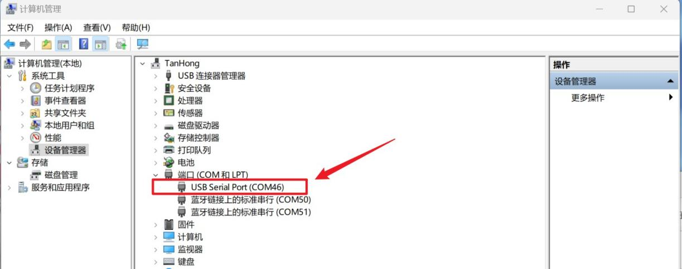

Figure 3 Device Manager

  - Installation of Host Computer Display Software
After decompressing the software package of the host computer using a decompression tool (such as WinRAR), open the folder of the host computer display software and locate the application "ms_ipc_rd_tool_V2.0.exe", as shown in Figure 4.

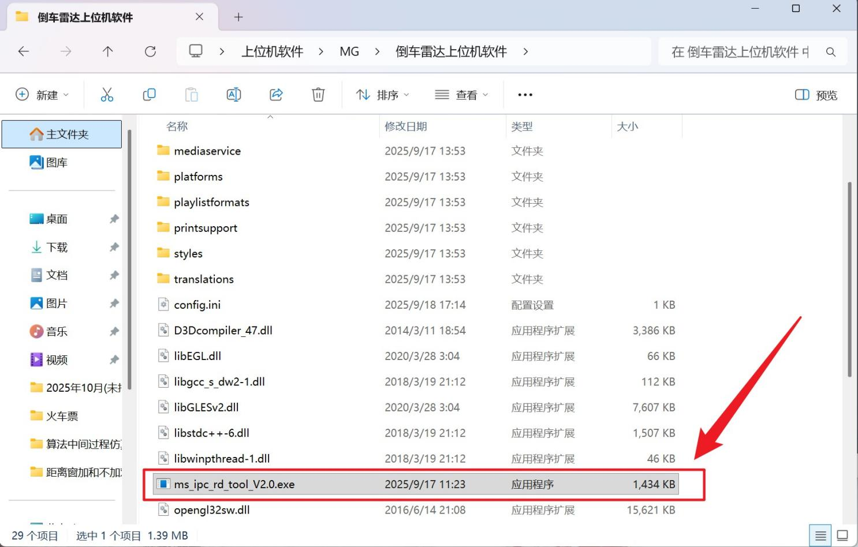
Figure 4 "Upper Computer Software of Reverse Parking Radar" folder

Double-click to run "ms_ipc_rd_tool_V2.0.exe", and the upper computer software will display as shown in Figure 5.
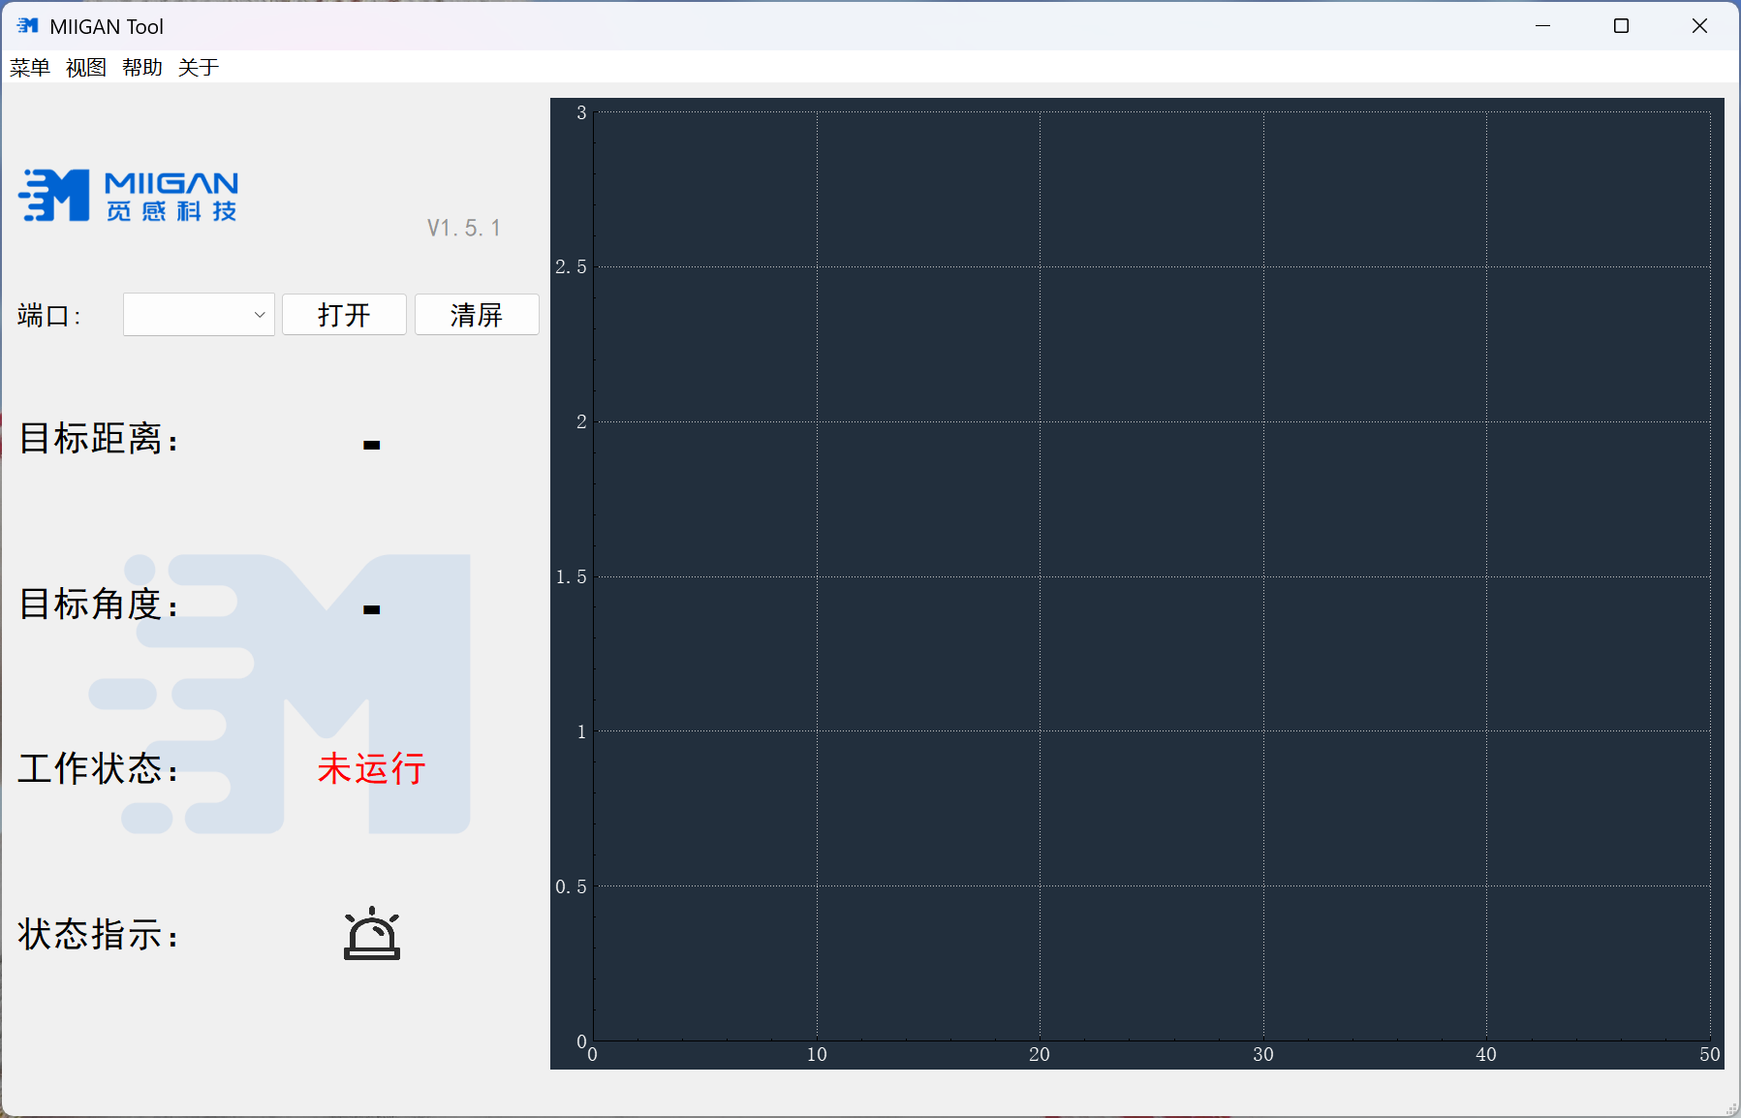
Figure 5: Main interface of the upper computer software after it is running
- Radar Installation Instructions
  - Radar Module Shape/Field of View
This set of Demo adds the angle measurement function, which is used to obtain the pitch (vertical) angle information. Therefore, when installing the radar, attention should be paid to the direction of the radar module. The radar can be installed horizontally or slightly tilted upwards according to the vehicle model. As shown in Figure 6.
Note: It is recommended that the angle measurement be used for ground interference elimination. The radar can also be rotated 90 degrees, and the angle measurement is used to distinguish the left and right of the target, but ground interference cannot be completely filtered out, and false alarms may occur.
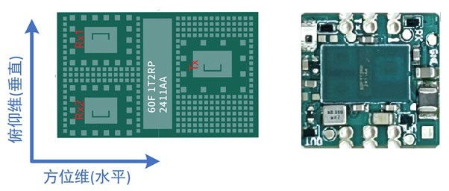
Figure 6: Schematic diagram of the shape of the radar module
The front of the radar module is the antenna surface. There should be no obstructions or any items (especially metal objects) attached to it. Otherwise, it will affect the radar's FOV detection and angle measurement performance.
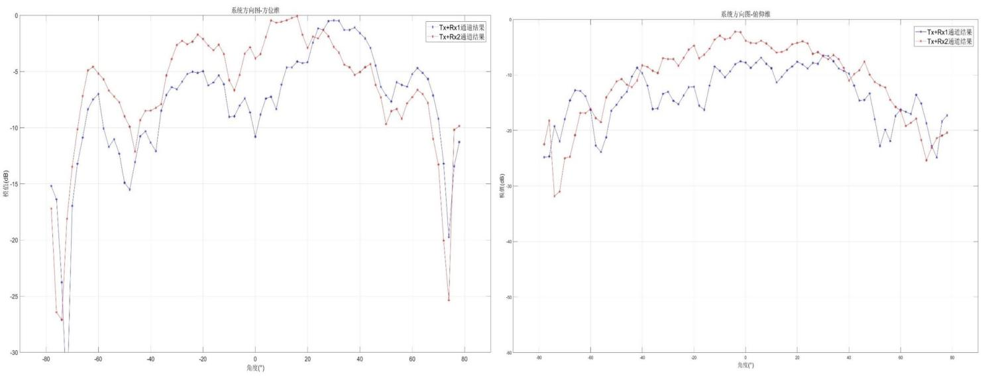
The FOV performance of the radar module is shown in Figure 7.
Figure 7 FOV of the radar module (left: azimuth dimension, right: elevation dimension)

  - Installation Instructions
Just fix the radar module to the installation position using double-sided adhesive tape or the housing. When installing the radar in the rear of the vehicle for use, please note:
- Place the radar flat, or tilt it slightly upwards according to the vehicle model;
- The installation height (distance from the ground) should be > 0.45m;
- The radar needs to be rotated 90° so that Rx1 and Rx2 are perpendicular to the ground, for angle measurement in the elevation dimension, as shown in Figure 6.
- Upper Computer Display Software Usage
This section describes the usage of the upper computer software.
  - Interface Display Instructions
    - Main Interface
After completing the deployment of the upper computer software as described in Chapter 3.2, run the "Cheng_Tech_Tool_V1.3.0.exe" program. The upper computer display software interface is shown in Figure 8.

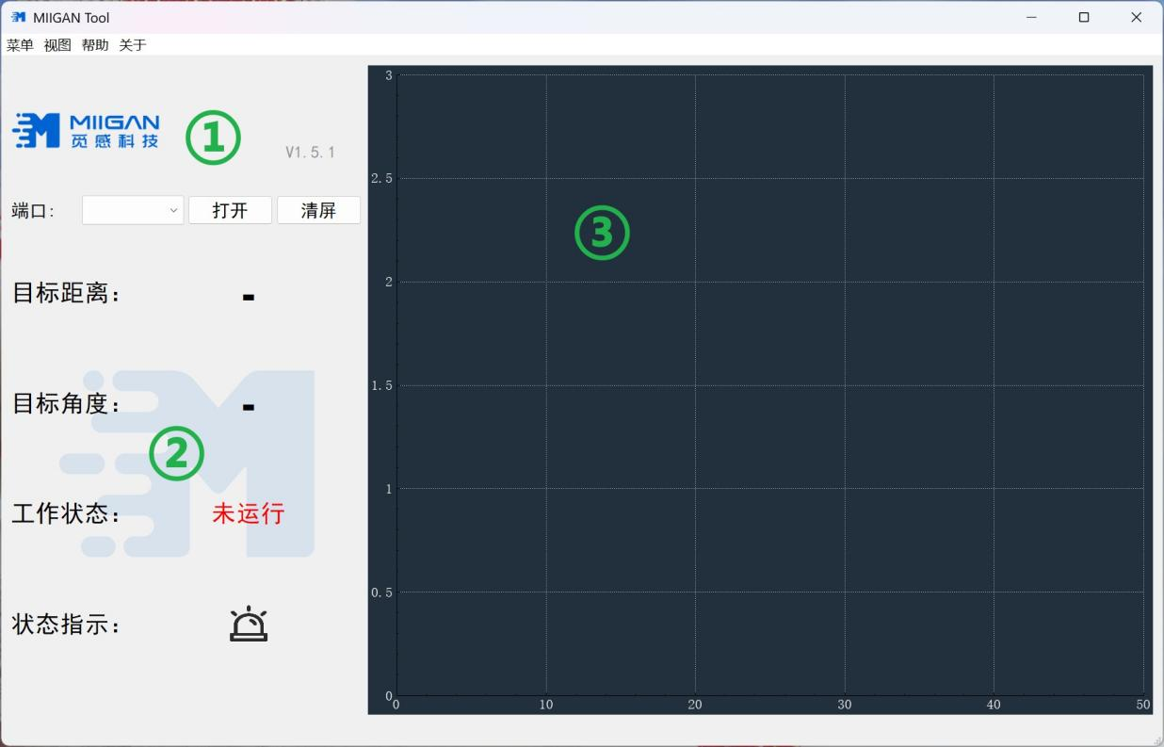
Figure 8 Main Interface

There are 5 display areas in the interface, and the contents and purposes of each area are shown in Table 3 as follows.
Table 3 Display Contents and Purposes of the Main Interface

Serial Number | Content | Explanation
① | Port Selection Area | According to the serial port, select the corresponding COM port to open: Open the COM connection for communication; Clear the screen: Clear the data displayed on the screen
② | Status indicator area | Target distance: When no target is detected, it displays "---"; when a target is detected, the target distance is displayed in real time (for multiple targets, only the distance of the nearest target is shown), in units of "meters"; Working status: "Not running" or "Running";  Status indication: When there is no alarm, it shows green; when there is an alarm, it shows red.
③ | Target distance R display area | Real-time display of target distance (radial distance from the target to the radar), in units of "meters", displays 0 when no target is detected;  X-axis: Frame number (for sliding window display of historical multiple frame results);  Y-axis: Target distance (meters), shows the nearest target distance.

    - Secondary Menu
On the menu bar at the top of the main interface, click the "Menu" and "View" buttons to enable the expansion function, as shown in Figure 9.
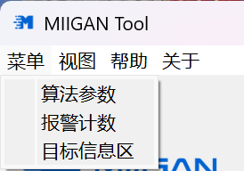
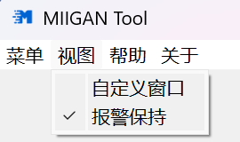
Figure 9 Secondary Menu
The purposes of the 5 options corresponding to the secondary menu are shown in Table 4 as follows.
Table 4 Functions of the Secondary Menu

Category | Name | Explanation
Menu | Algorithm parameters | Open the sub-interface for algorithm parameter configuration, and configure the parameters of the lower-level software online.
 | Alarm count | Open the alarm count sub-interface, which can count the number of alarms and the duration during the radar operation process.
 | Target information area | Open/Close the "Alarm Information Area" at the lower left corner of the main interface.
View | Custom window | Open the custom window to adjust the display range of the "Target Position XY Display Area" and the "Target Distance R Display Area" on the main interface.
 | Alarm on standby | Open/Close the "Alarm Hold" function. When the "Alarm Hold" function is enabled, for an already alarmed target, if it remains stationary, the "Status Indication Area" will retain the last distance. On the algorithm parameter configuration page, you can set the holding distance and holding time.
      - Algorithm Parameter Configuration
By opening the secondary menu, the "Algorithm Parameter Configuration" sub-interface can be accessed. Two sub-pages, "Function" and "Sensitivity", can be selected to set different parameters, as shown in Figures 10 and 11.

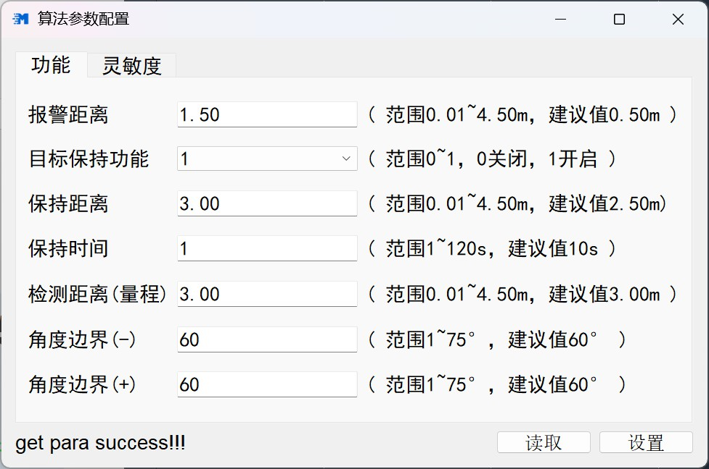

Figure 10 "Function" sub-interface

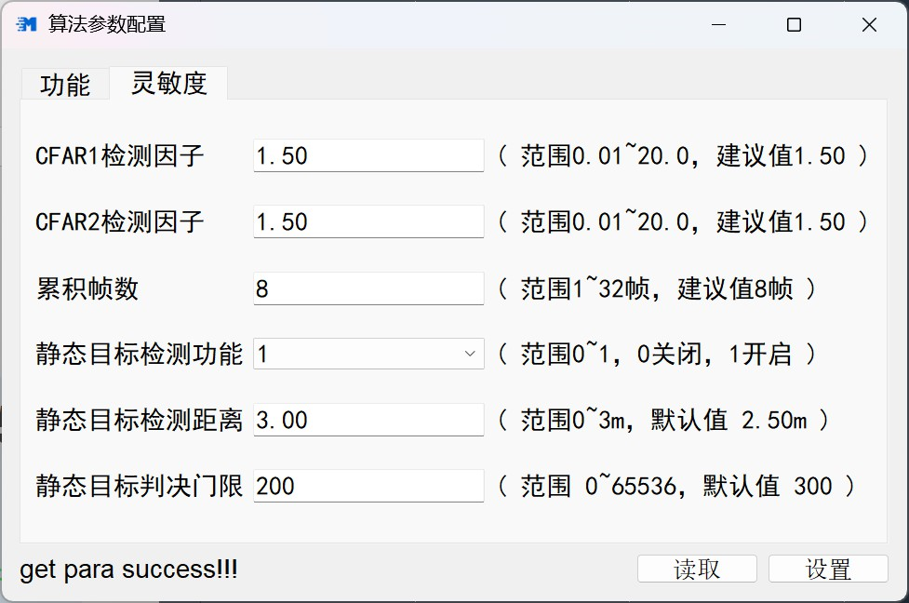

The functions of the buttons are shown in Table 5.
Figure 11 "Sensitivity" sub-interface

Table 5 Algorithm Parameter Configuration Function

Category | Name | Explanation
Configuration | Read | Read the algorithm parameter values in the current lower-level machine software. When opening the "Algorithm Parameter Configuration" sub-interface for the first time, this operation needs to be performed.
 | Settings | Send the algorithm parameter values online to the lower-level machine software. When modifying the algorithm parameter values, this operation must be carried out; only then will the lower-level machine software update the parameters.
Function | Alarm distance | Radar alarm distance: When the target distance is less than the alarm distance parameter, it will be displayed as an alarm (red light).  Range: 0.01 - 4.50 meters. Default value: 0.50 meters.  Note: This parameter only affects the color of the indicator light displayed by the upper-level machine software, and has no effect on the lower-level machine.
 | Target retention function | Enable or disable the target retention function
 | Keep a distance | Set the range of the retention function. Within this range, if the target is lost, it will maintain the last distance.  Range: 0.01 - 4.50 meters. Default value: 3.00 meters.
 | Maintain time | Set the duration for the retention function. This is the time during which the last distance information is maintained when the target is lost. If this time is exceeded, the information will be cleared. The range is 1 to 120 seconds, with the default value being 10 seconds.
 | Detection distance (range) | The maximum detection range (range) of the radar.  Range: 0.01 - 4.50 meters. The default value is 3.00 meters.
 | Angle boundary (-) | Set the maximum negative angle for radar angle measurement. Any angle exceeding this limit will be excluded. The range is from 1 to 75 degrees, with the recommended value being 60 degrees.
 | Angle boundary (+) | Set the maximum positive angle for radar angle measurement. Any angle exceeding this limit will be excluded. The range is from 1 to 75 degrees, with the recommended value being 60 degrees.

Category | Name | Description
Sensitivity | CFAR1 detection factor | The CFAR threshold limit ranges from 0.01 to 20.0, with the recommended value being 1.50.  The larger the value, the lower the sensitivity, fewer false alarms, but weak targets are more likely to be missed.
 | CFAR2 detection factor | The CFAR threshold limit ranges from 0.01 to 20.0, with the recommended value being 1.50.  The larger the value, the lower the sensitivity, fewer false alarms, but weak targets are more likely to be missed.
 | Cumulative frame count | Multiple frame accumulation parameters, ranging from 1 to 32, with the recommended value being 8.  The larger the value, the higher the sensitivity, making it easier to detect weak targets, but with a greater delay.
 | Static target detection function | Enable or disable the static target detection function. If this function is disabled, the radar will only detect relative moving targets and will miss those that are relatively stationary.
 | Static target detection distance | Set the detection range of the static target detection function. Within this range, even if a static target is detected, it will be output.  Range: 0.01 to 4.50 meters. Default value: 3.00 meters.
 | Static target decision threshold | Sensitivity of static target judgment, range: 0 to 65535. Recommended value: 250. The larger the value, the lower the sensitivity, with fewer false alarms, but weak targets are more likely to be lost.

2)Customize window configuration
Open the "Customize Window" sub-interface through the secondary menu, as shown in Figure 12.
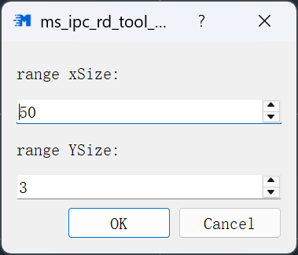
Figure 12 "Custom Window" Sub-interface
The functions of the buttons are shown in Table 6 as follows.
Table 6 Configuration Functions of Custom Window
Category | Name | Description
Function | OK | After modifying the function parameters, save the parameter design.
 | Cancel | Exit the custom window configuration.
 | range xSize | Set the horizontal coordinate range of the display area for the target distance R on the main interface.
 | range ySize | Set the vertical coordinate range of the display area for the target distance R on the main interface.
  - Usage Method
After the radar module is powered on and starts working normally, open the upper-level software on the test computer. In the interface, select the corresponding serial port in the port selection area, and click the "Open" button. Once the communication is normal, as shown in Figure 13.
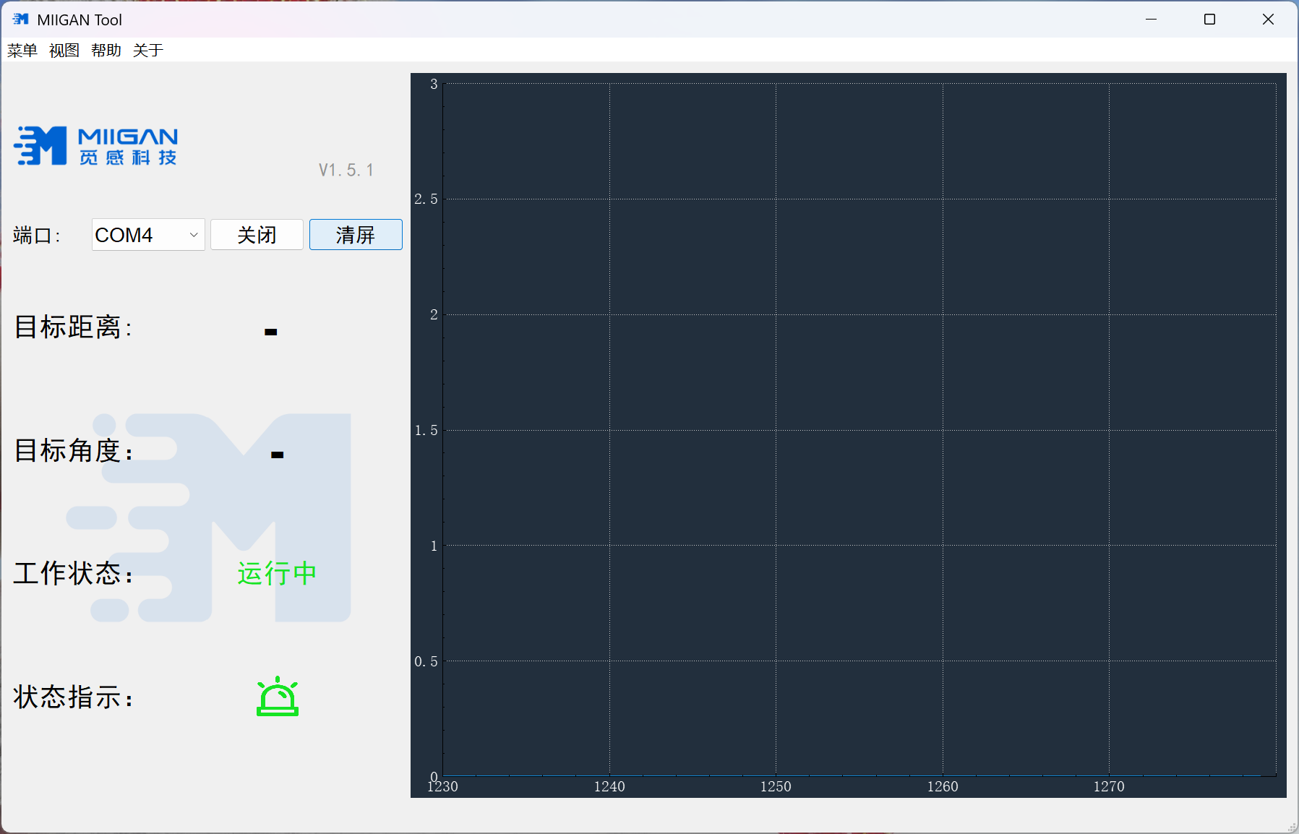
Figure 13 Status after starting the work
    - Alarm Status
When the radar issues an alarm, the upper computer software displays it as shown in Figure 14.
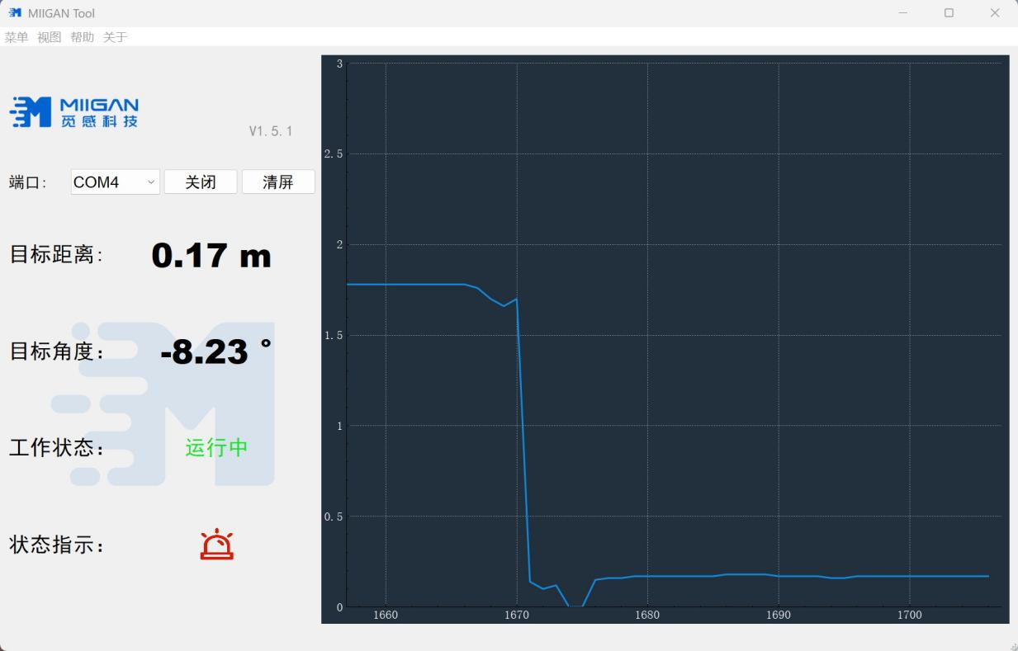
Figure 14 Alarm Status
    - Non-Alarm State

When the radar does not issue an alarm, the upper-level computer software displays it as shown in Figure 15.
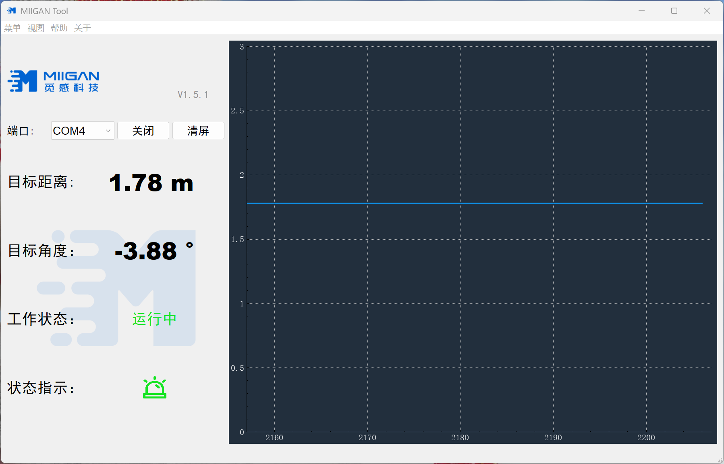
Figure 15 Unalarmed State
- Daily Use Precautions
Correct and reasonable use of the product has a significant impact on its reliability. During use, the following points should be noted:
- Before use, carefully read the user manual and install and connect the equipment correctly according to the manual;
- Operate strictly in accordance with the provisions of the user manual. Connect the cables correctly before powering on;
- Do not randomly disassemble the cables, equipment or components to avoid causing accidental damage;
- When a fault occurs, have a professional person correctly analyze and locate the fault based on the fault phenomenon. Do not expand the fault range artificially;
- When the fault is difficult to be eliminated, please contact the manufacturer and have the manufacturer provide guidance or send it back for repair.
- Common Problems and Solutions
  - Communication Failure Issue
After the test environment is set up, clicking "Open" in the upper-level software results in communication failure, and no data can be received. The working status shows "Not Running". Please check the following reasons:
a) Check if the cable connections are properly made;
b) Verify if the COM port driver in the computer device manager is functioning correctly and try restarting the computer;
c) Confirm if the port number selection in the upper computer software is correct;
d) Replace the USB-to-serial port module and the radar module.
  - Problem of Failure to Trigger Alarm Correctly
After the test environment was set up, clicking "Open" in the upper computer software resulted in normal serial port communication, but a moving object entered the radar FOV. The upper computer software did not correctly indicate the alarm status (note: if COM communication fails, please refer to Section 7.1 of this document for troubleshooting). Please check the following reasons:
a) Verify whether the "alarm distance" parameter setting is correct. The operation steps are detailed in Section 5.1 of this document.
b) Check if there are any obstructions, dirt, or foreign objects on the front (antenna surface) of the radar.
c) Confirm if the installation direction of the radar module is correct.
d) Check if the radar module is functioning properly and replace it if necessary.
  - Explanation of Radar Detection Blind Zone
Due to the limited detection angle range of the radar, the detection rate is high within the ±60° range in both the horizontal and pitch dimensions. When the angle exceeds ±60°, the false alarm rate will significantly increase. Therefore, when installing the radar, the blind zone caused by the installation position needs to be considered. The appropriate installation position and tilt angle should be adjusted based on the application requirements. The blind zone diagrams are shown in Figures 16 and 17.

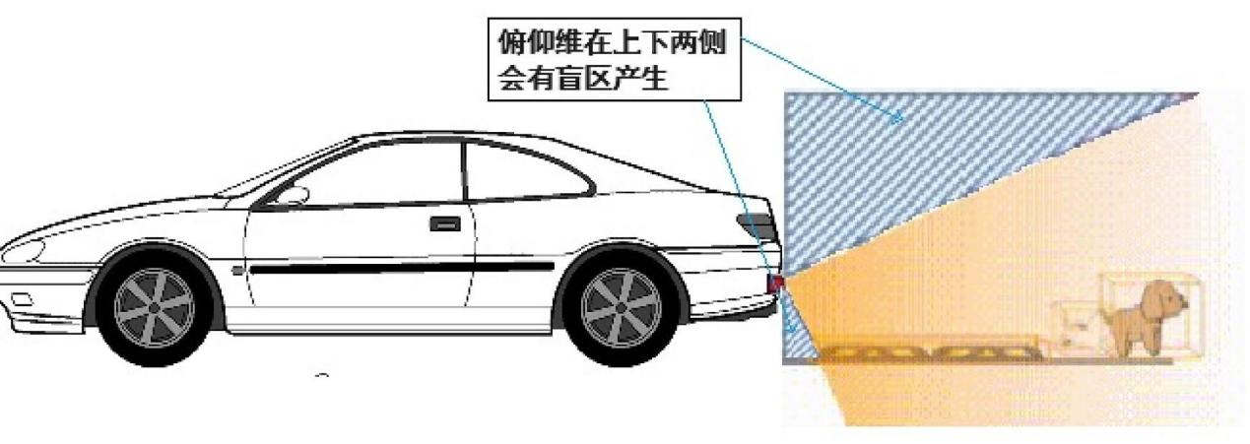

Figure 16 Radar Detection Area Diagram (Pitch Dimension)

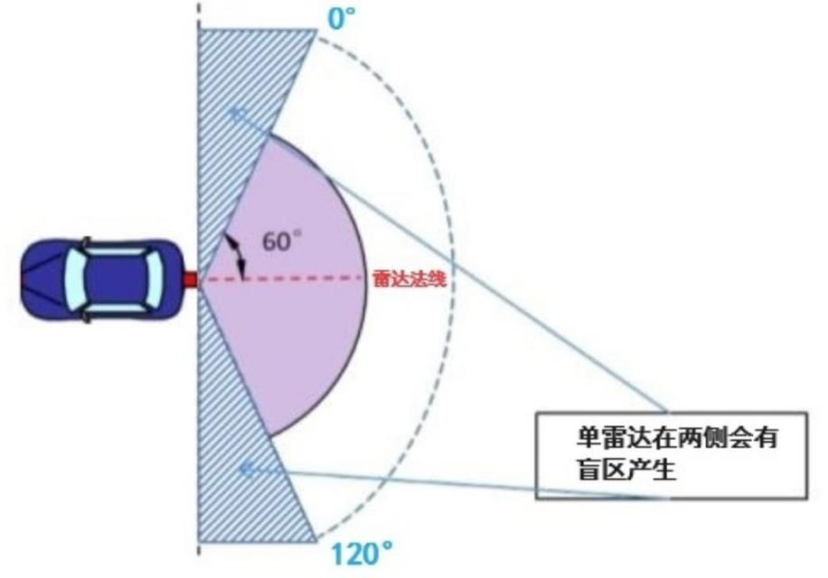

Figure 17 Radar Detection Area Schematic Diagram (Horizontal Dimension)

